

Project Management System

**Index**

1. Introduction ------------------------------------------------ 3

1.1 Intended audience ------------------------------------------------ 3

1.2 Project purpose ------------------------------------------------ 3

1.3 Key project objective ------------------------------------------------ 3

1.4 Project scope and limitation ------------------------------------------------ 3

1.5 Functional overview ------------------------------------------------ 3

1.5.1Header files ------------------------------------------------ 4

1.5.2 Functions ------------------------------------------------ 4

2. Design overview ------------------------------------------------ 5

2.1 Design objective ------------------------------------------------ 5

2.2 Design alternative ------------------------------------------------ 5

2.3 User interface paradigms ------------------------------------------------ 5

2.4 Error detection/ Exceptional Handling ------------------------------------------------ 6

2.5 Performance ------------------------------------------------ 6

2.6 Maintenance ------------------------------------------------ 6

3. System architecture ------------------------------------------------ 6

3.1 Structure ------------------------------------------------ 6

4. Environment description ------------------------------------------------7

4.1 Time zone support ------------------------------------------------7

4.2 Language support ------------------------------------------------7

4.3 User desktop requirement ------------------------------------------------7

4.4 Server-side requirement ------------------------------------------------7

4.4.1Deployment consideration ------------------------------------------------7

4.4.4 Integration requirements ------------------------------------------------7

4.4.5 Network ------------------------------------------------7

4.5 Configuration ------------------------------------------------7

4.5.1 Operating system ------------------------------------------------7

5. Reference ------------------------------------------------7

1. **Introduction: -**

Project Management System is the model for overseeing the execution of a project .It is designed to help business and individuals track projects, tasks and schedules. Project management provides structure and control of the project environment, so that the agreed activities will produce the right products or services to meet the organisation expectations.

* 1. **Intended Audience: -**

The audience set for this project would include employees and managers working in a project management system as well as for their clients which are the customers that use services from these organisation.

* 1. **Project Purpose: -**

The purpose of project management system is to plan and manage a project to successfully complete it’s listed goals and deliverables. It helps us to foresee the risk and challenges that could detail the completion a project. It is used to help business and individuals track projects, task and schedules.

* 1. **Key Project Objectives: -**
* Create task list with easy to use checklist.
* View and add details for each task.
* Comment on any step of a task
* Set remainders for others on specific times and dates.
* Scheduling tasks and projects which are organised by date and time.
* Adding detailed reports of the project.
  1. **Project scope and limitation: -**

Primarily, the scope of the project management system features to ensure managing operations .The main of the project management system is to plan and execute and track projects of any size assigning tasks and prioritize what’s most important to your team. Set project timelines and milestones track project and manage teams entire workload all in one place

* 1. **Functional Overview: -**

1.5.1 Following header files are included in the program:

* #include <stdio.h>
* #include <string.h>
* #include <stdlib.h>
* #include<unistd.h>
  + 1. Login
* Employee: Employee logins by entering employee id , employee name ,phone number & email address.
* Manager: Manager logins by user name &password
  + 1. Employee
       1. Employee registration

The employee can register by entering name , id,email address and phone number. Every Phone number entered should be unique.

* + - 1. Employee login

The employee login by entering employee name , employee id and password.

* + - 1. Checking his project details and deadline

In this function employee can login and check his project details,howmany projects he is assigned its end date .

* + 1. Manager
       1. Login

The manager can login by entering name and password.

* + - 1. Add employee to project

The manager takes care of adding employee to project.

* + - 1. Remove employee from project

The manager take care of remove employee from the project

* + - 1. Delete and checking project details

The project is completed then assign its status as closed.

* + - 1. Adding report

The manager add report after calls and meetings etc..

# 2.Design Overview: -

Project Management system comprises of following modules

## Design Objectives: -

* Create task list with easy to use checklist.
* View and add details for each task.
* Comment on any step of a task
* Set remainders for others on specific times and dates.
* Scheduling tasks and projects which are organised by date and time.
* Adding detailed reports of the project.
  1. **Design Alternative****: -**

We have used linked list instead of stack & queue as Insertion and Deletions operations are fast and easier in linked list. Memory allocation is done during run-time. (i.e., no need to allocate any fixed memory.

### User Interface Paradigms: -

The project Management System gives a user an option to have its task management stored on a system file. A system always works faster than a person can. User is given an interface to create a new account , an option to deposit and check their assigned projects and team members

. A specific set of tasks are given interface to edit details of the project & delete the project, to

report the calls.

### 

### Error Detection / Exceptional Handling: -

* If the employee doesn’t have any pre-existing account , the user has to register one else it won’t perform any functions and would give “not found” or “Invalid entry” error.
* While creating the account ,employee should first enter the name followed by phone number else it will display “Already exist” and “Invalid length ” error for the respective cases. We check the validity of the name ,email address & phone number entered with the help of exception handling .If the name entered has the length less than 5 or greater than 25 or the phone number entered is either already existing or of not length 10 digit , an error message will be flashed.

### Performance: -

### The system will work on the user’s terminal. The performance shall depend upon hardware components of the organisation and the internet connection

### Maintenance: -

Very little maintenance should be required for this setup. An initial configuration will be the only system required interaction after system is put together. The only other employee maintenance would be any changes to settings after setup, and any specified special cases where user settings or history need to be changed. Physical maintenance on the system’s parts may be required, and would result in temporary loss of data or Internet. Upgrades of hardware and software should have little effect on this project but may result in downtime.

**3.SYSTEM ARCHITECTURE: -**

**3.1 Structure Details:**

The system consists of two structures :

* Employee:

Employee can login and check his project details, how many projects he is assigned its end date his co-workers, etc

* Manager:

He needs to take care of adding employees to projects.

delete project, remove employee from project. When the project is completed, assign its status as closed and .

Adding report after meeting, calls, etc

**3.2 Flow-Chart:**

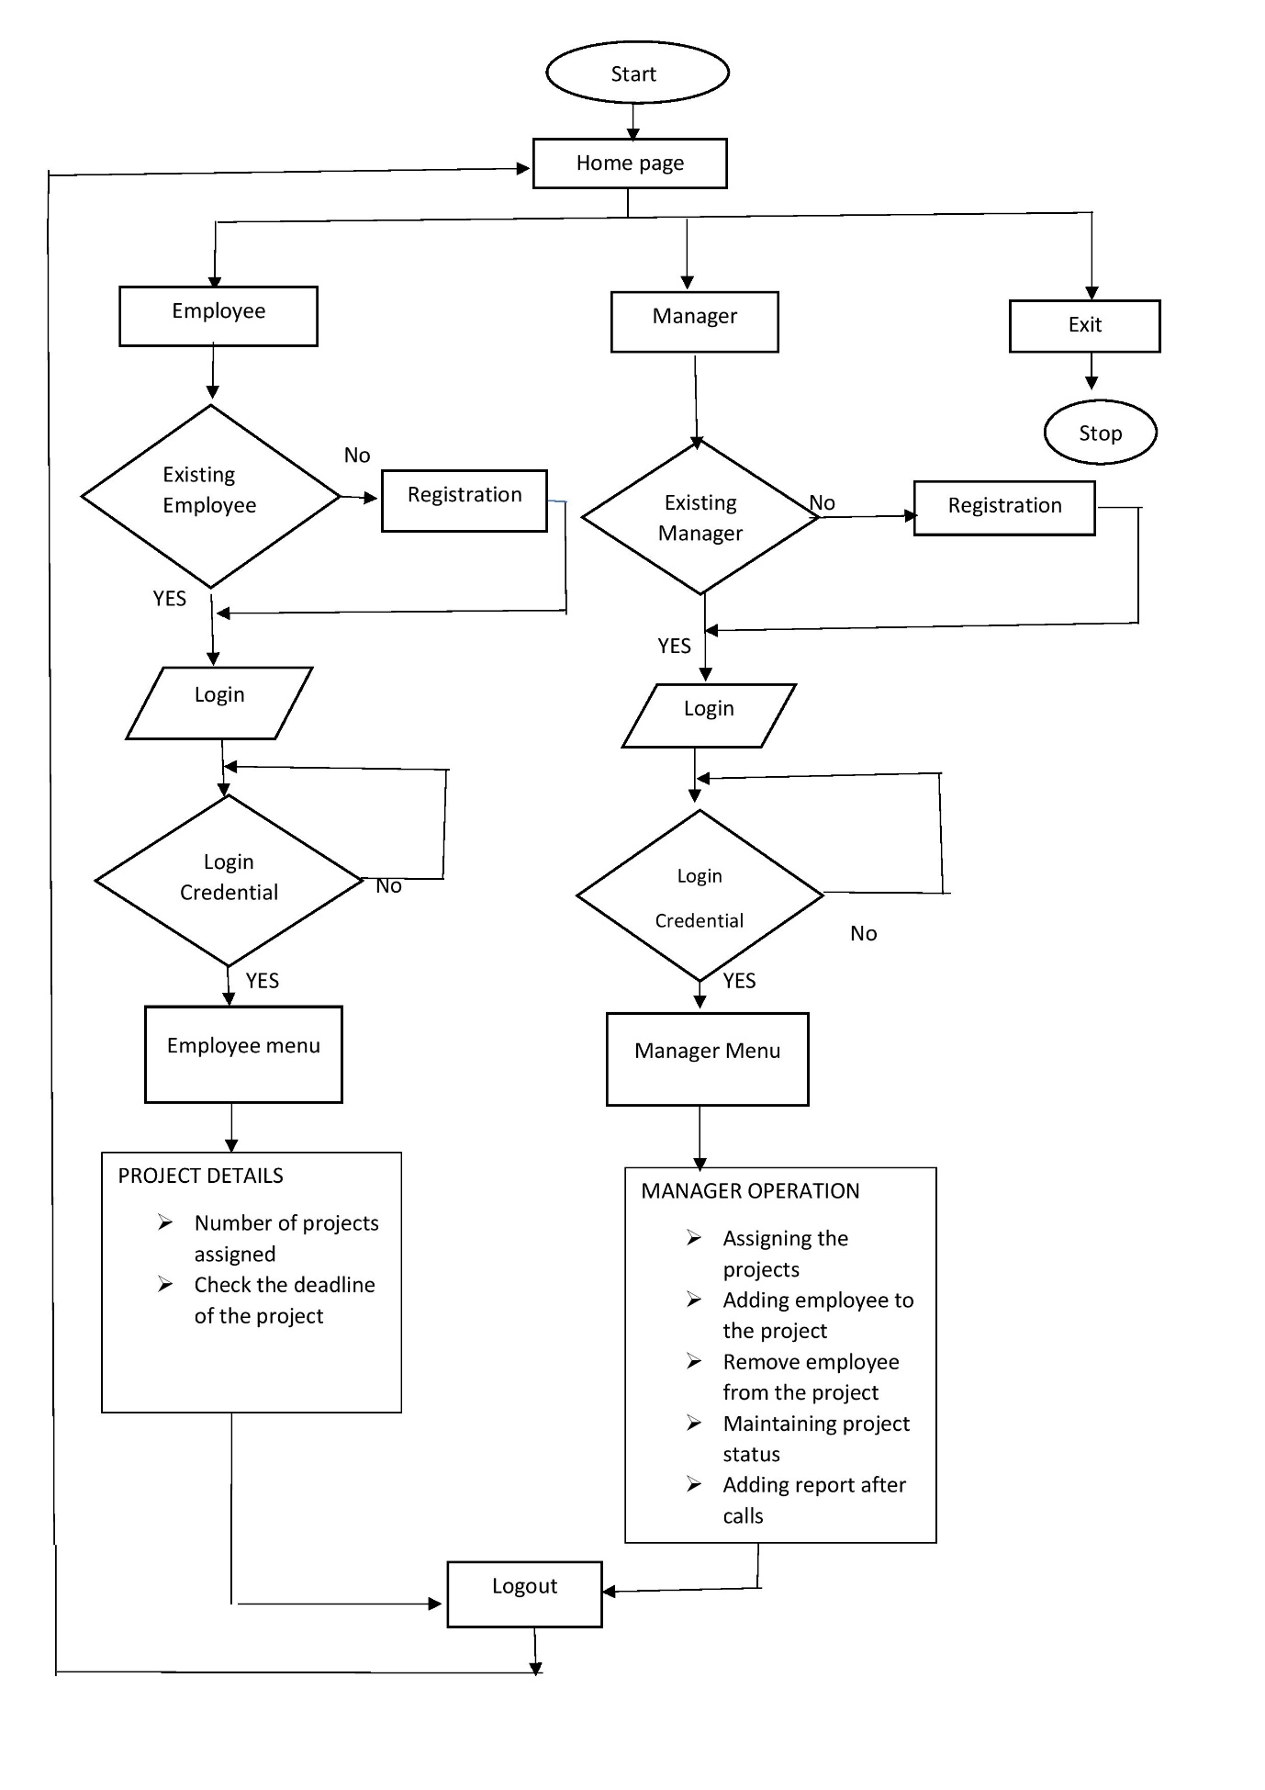

**3.3 ER-Diagram:**

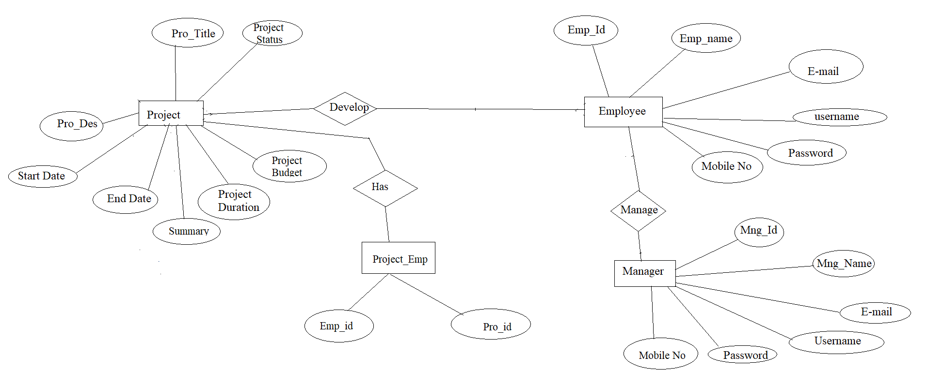

**4.Environment Description: -**

* 1. **Time Zone Support: -** IST- Kolkata
  2. **Language Support: -** English
  3. **User Desktop Requirements: -**
* 64-bit processor, 1 GHz or faster
* At least 10 GB free hard drive space
* At least 1 GB RAM **Server**
  1. **Side Requirements: -**
* 64-bit processor, 1 GHz or faster
* At least 2 GB free hard drive space
* At least 1GB RAM

4.4.1.Deployment Considerations: -

* + Local storage is used
  + No network latency to consider
  + To scale buy a bigger CPU, more memory, larger hard drive, or additional hardware

4.4.2Integration Requirements: -

* Language: - C
* Tools: - Valgrind, Makefile ,Strace
* Complier: - gcc
* Linux Environment

4.4.3 Network: - End to End

**4.5 Configuration: -**

*4.5.1.* Operating System: - Linux environment

**5.Reference: -**

The references are:

* https://www.programiz.com/dsa/linked-list
* https://www.javatpoint.com/file-handling-in-c
* https://www.educative.io/answers/how-to-create-a-simple-thread-in-c